Khmer Text-to-Speech: A Literature Review

1. Overview
VoxCPM2, Higgs TTS 3, Fish Audio S2 Pro, and MMS-TTS were tested over a fixed 100 Khmer sentences (50 pure Khmer, and 50 code-switched). Out of the four model, only VoxCPM2, and Higgs-v3-TTS was able to consistently output Khmer speech audio without hallucinated to another language. The summary of both models can be described as follow:
- VoxCPM2 (OpenBMB, 2B parameters, Apache-2.0) — a tokenizer-free diffusion-autoregressive model that predicts continuous acoustic latents rather than discrete codec tokens. Khmer is one of its 30 documented languages, with a self-reported 2.05% CER.
- Higgs TTS 3 (Boson AI, 4B parameters, research/non-commercial) — a neural-codec language model on a Qwen3-4B backbone with a semantically-grounded audio tokenizer. Khmer is undocumented, yet works.
2. Background
Modern Text-to-Speech model can be deconstructed into 3 core components as shown in Table 1 below.
Stage | Job | Typical realisation
Text frontend | Turn written text into a sequence the model can condition on | A byte/BPE tokenizer, or a G2P phonemizer plus lexicon
Acoustic model | Predict a compact intermediate representation of the speech | An autoregressive transformer, a diffusion model, or both
Vocoder / decoder | Turn that representation into a waveform | A neural codec decoder, a GAN vocoder, or a VAE decoder
Table 1: Three Core Component of a Modern Text-to-Speech Model
Speech model can be broken into 2 architecture in terms of acoustic: Discrete, and Continuous.
2.1 Discrete Tokens – Higgs TTS 3
A separate codec model, trained beforehand, which compresses audio into sequence of integers that act as vocabulary. Every chunk of audio gets mapped to the nearest entry in this learned codebook.
The limitation is that the codebook is a fixed, finite vocabulary of sound. If a language has specific sound, and pattern, that were not represented in the training data, the model would completely failed in generating those sounds.
2.2 Continuous Latents – VoxCPM2
The model predicts continuous vectors directly, either through regression or diffusion decoder. However, since there is no quantization steps, small prediction error can compound over long sequence, so the architecture needs constraint to stay stable.
3. VoxCPM2
A 2B-parameter language model predicts one continuous latent vector per four-frame patch of audio; a small diffusion transformer turns each predicted latent into acoustic features; a separately-trained variational autoencoder decodes those features to a waveform. Because the VAE takes 16 kHz features in and emits 48 kHz audio, super-resolution is built into the decoder rather than bolted on afterwards.
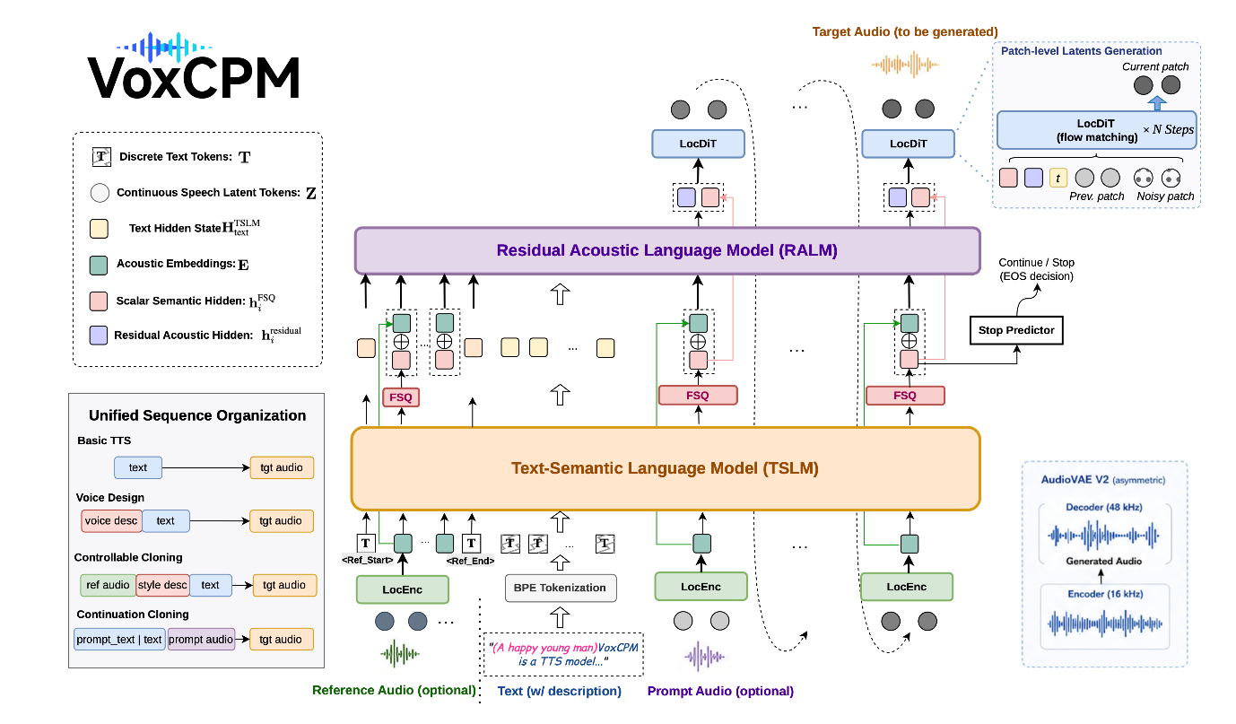
Figure 1: Overview of VoxCPM2 Model Architecture
3.1 Training VoxCPM2
Property | Value | Why it matters
patch_size | 4 | One LM step covers 4 VAE frames. Sequence length ≈ chars + duration×25/4.
feat_dim | 64 | Latent width the diffusion transformer predicts.
AudioVAE frame rate | 25 fps | One second of audio ≈ 25 frames ≈ 6.25 LM positions.
max_length | 8192 | Training sequence cap; longer samples are dropped by the packer.
Encoder sample rate | 16 kHz | Training audio must be 16 kHz — the validator hard-fails on a mismatch.
Output sample rate | 48 kHz | Free super-resolution; you do not supply 48 kHz data.
scalar_quantization_latent_dim | 512 | Scalar quantisation on the latent, not a VQ codebook — this is the “tokenizer-free” part.
inference_cfg_rate | 2.0 | Classifier-free guidance default, exposed as --cfg-value.

Training data is a JSONL file, one JSON object per line:
{"audio": "clips/km_0001.wav", "text": "<Khmer transcript>"}
{"audio": "clips/km_0002.wav", "text": "<Khmer transcript>", "ref_audio": "clips/km_0001.wav"}

Field | Required | Notes
audio | yes | Path to a WAV. Relative paths resolve against the manifest's directory.
text | yes | Exact transcript. Raw Khmer — no phonemes, no segmentation, no romanisation.
ref_audio | no | A different clip from the same speaker. Trains the voice-cloning path.
duration | no | Seconds. Lets the length filter skip opening every file — worth it above a few thousand rows.
dataset_id | no | Integer tag for mixing corpora; lets the model condition on source.

The package ships a validator; run it before spending GPU hours. It reports total hours, duration range and text-length distribution, and hard-fails on missing files, sample-rate mismatches, empty transcripts and malformed JSON.
voxcpm validate --manifest data/train.jsonl --sample-rate 16000 --verbose

Audio Requirements
Requirement | Value | Enforcement
Sample rate | 16 kHz | Hard failure in validate on a mismatch.
Format | WAV | Recommended; anything soundfile reads will load.
Clip duration | 3–30 s | Over 30 s warns (OOM risk); under 0.3 s warns as too short.
Trailing silence | < 0.5 s | Not cosmetic — see the callout below.
Loudness | Normalised | Consistent level across the corpus.
Trailing silence is the most-cited cause of failure in the official FAQ
Clips that end with a long silent tail teach the model that utterances do not end, and it learns to keep generating — producing exactly the runaway output that made Fish Audio S2 unusable in our evaluation. Trim aggressively. This is the highest-value preprocessing step available, and it costs nothing
Data Requirements
Goal | Method | Data | Realistic for Khmer?
One specific Khmer voice | LoRA r=32 | 5–50 clips | Yes — an afternoon of recording.
Better Khmer prosody, or a domain (news, IVR, education) | LoRA r=32–64 | 50–500 clips | Yes — the highest-value target.
Large-scale Khmer customisation | Full fine-tune | 1000+ clips | Plausible with OpenSLR SLR42.
Adding a language from scratch | Full fine-tune, lr 1e-5 | 500+ hours | Not applicable — Khmer is already in.

Finetuning
The LoRA configuration (conf/voxcpm_v2/voxcpm_finetune_lora.yaml), abbreviated to the fields that carry decisions:
pretrained_path: /path/to/VoxCPM2/
train_manifest: /path/to/train.jsonl
val_manifest: /path/to/val.jsonl

sample_rate: 16000 # must match your audio
out_sample_rate: 48000
batch_size: 16
grad_accum_steps: 1
num_iters: 1000
valid_interval: 500
save_interval: 500

learning_rate: 0.0001 # 1e-4 for LoRA; 1e-5 for a full fine-tune
weight_decay: 0.01
warmup_steps: 100
max_batch_tokens: 8192

lambdas:
loss/diff: 1.0 # diffusion loss on the latent
loss/stop: 1.0 # end-of-utterance prediction

lora:
enable_lm: true # adapt the MiniCPM4 backbone
enable_dit: true # adapt the diffusion transformer
enable_proj: false
r: 32
alpha: 32
dropout: 0.0

- Choosing the rank. r=32 clones a speaker; r=64 is for style or language work — which is what Khmer prosody correction is. Set alpha to r or 2r.
- Keep both adapters on. The backbone carries linguistic behaviour, the DiT carries acoustic detail, and Khmer adaptation wants both. enable_proj stays false.
- For a full fine-tune, delete the lora: block entirely and drop the learning rate tenfold to 1e-5.
# single GPU
python scripts/train_voxcpm_finetune.py --config_path conf/voxcpm_v2/voxcpm_finetune_lora.yaml

# multi-GPU
CUDA_VISIBLE_DEVICES=0,1,2,3 torchrun --nproc_per_node=4 \
scripts/train_voxcpm_finetune.py --config_path conf/voxcpm_v2/voxcpm_finetune_lora.yaml

Monitor with TensorBoard: loss/diff should fall steadily, loss/stop should stabilise early, and grad_norm and lr should behave. But select checkpoints by ear, not by loss — the FAQ is explicit that on small datasets the model begins ignoring the text input within a few hundred steps. Checkpoint every 500 steps and listen to each one; the best checkpoint is frequently not the last.
LoRA adapters hot-swap at runtime, so one base model can serve several Khmer voices from a single set of 2B weights:
from voxcpm import VoxCPM

model = VoxCPM.from_pretrained(
"openbmb/VoxCPM2",
lora_weights_path="/path/to/checkpoints/lora/latest",
)
wav = model.generate(text="<Khmer text>")

Failure Mode
Symptom | Cause | Fix
Output ignores the text; reproduces training clips | Overfitting — the classic small-dataset failure, and it arrives fast | Fewer steps, lower LR, more data, lower LoRA rank. Checkpoint often.
Generation runs away, or long trailing noise | Trailing silence > 0.5 s in the training clips | Re-trim the corpus. The most common cause per the official FAQ.
Loss will not converge | Bad transcripts, wrong sample rate, misaligned audio | Re-run voxcpm validate; spot-check alignment by hand.
Out of memory | Batch too large | Lower batch_size / max_batch_tokens, raise grad_accum_steps.
Khmer improved, English and Chinese degraded | Catastrophic forgetting | Mix Chinese/English data in — or use LoRA and disable it for other languages.

